Wood Carving with Knives Supply List

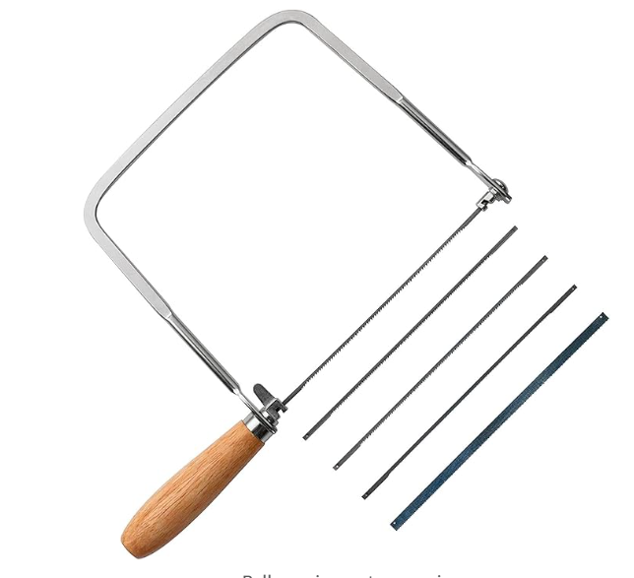 | Coping Saw used for roughing out three dimensional carvings.
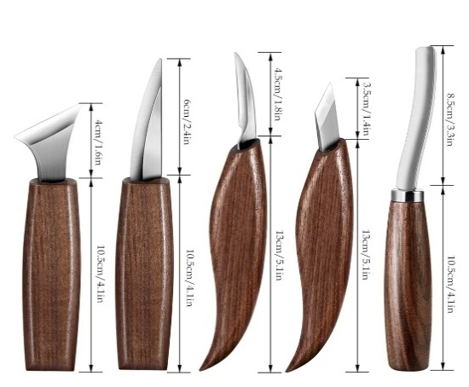 | Sloyd Knife is used for general roughing out of carvings.
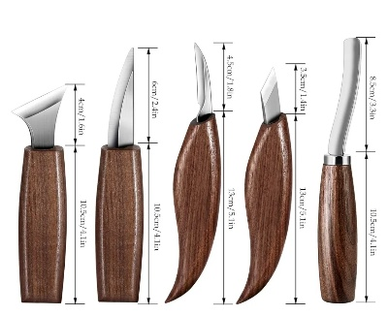 | Detail Knife is used for fine detail cuts in tight areas.
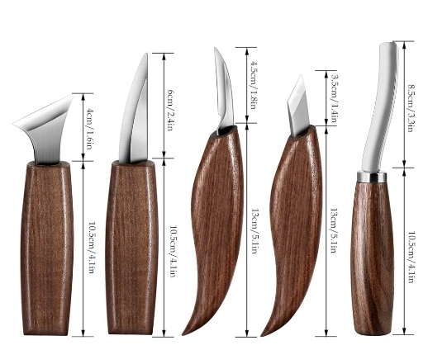 | Geometric Chip Carving Knife is used in chip carving.  *Note: students attending classes that include chip carving need either the Geometric Chip Carving Knife or the Swiss style Chip Carving knife.
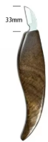 | Chip Carving Knife is used for chip carving in the Swiss and German tradition.  *Note: students attending classes that include chip carving need either the Geometric Chip Carving Knife or the Swiss style Chip Carving knife.
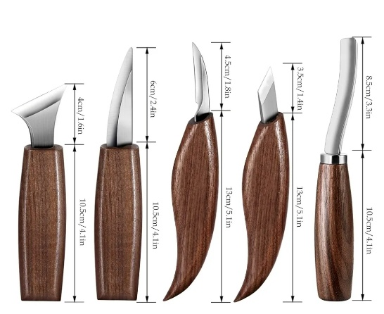 | Stab Knife is used for creating decorative elements in chip carving.
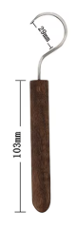 | Hook Knife is used for carving out the dished area of spoons and bowls.
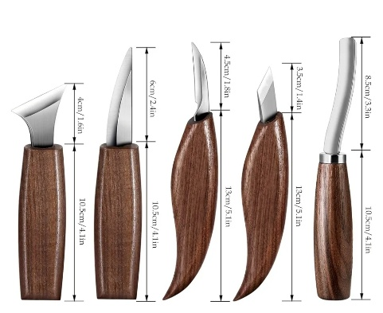 | Bent Gouge is used for carving out spoons, bowls, and reliefs.
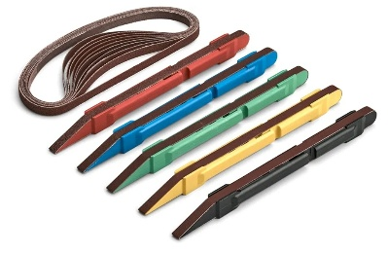 | Kit includes 4 color coded sticks and 5 belts each in 80, 120, 180, and 240 grits for detail sanding.  Students will need either type of detail sanding sticks.
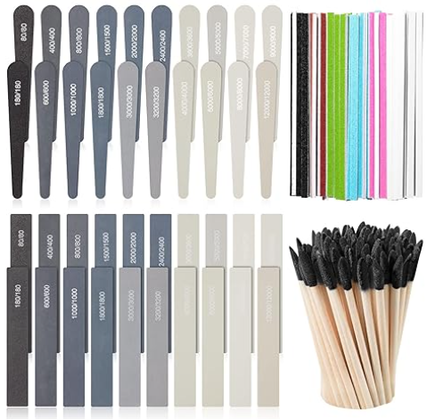 | 120 Piece Detail Sanding Set  Students will need either type of detail sanding sticks.

Feel free to use a coping saw, bow saw or a bandsaw to cut out the three-dimensional carving blanks.
Kakuri Coping Saw w/ Four Blades
https://www.amazon.com/dp/B000ALF4FA?psc=1&ref_=cm_sw_r_cp_ud_ct_CYSDGA744GTYYJ7G0WE7
Olson Coping Saw
https://www.amazon.com/dp/B001NI8N2K?psc=1&ref_=cm_sw_r_cp_ud_ct_YYZRPNPVA05PVVT1XRV2

Students may use any brand of carving knife, tools, or sharpening medium that they prefer. Below are some links to some cost-effective options.
Carving Knife Sets:
6 Piece Carving Knife Set
https://www.amazon.com/gp/product/B08T1JM6MY/ref=ox_sc_saved_image_9?smid=ACOU3OMD2MPWJ&th=1

5 Piece Carving Knife Set
https://www.amazon.com/dp/B0CG38FQD7/?coliid=I2J32KA4LWVBGF&colid=19V4117D9J70V&psc=1&ref_=list_c_wl_lv_ov_lig_dp_it_im

8 Piece Carving Knife Set
https://www.amazon.com/dp/B09V17FSX9/?coliid=I2LDTRQTOAOGDI&colid=19V4117D9J70V&psc=1&ref_=list_c_wl_lv_ov_lig_dp_it

Deluxe Carving Knife Set
https://www.amazon.com/dp/B0CG3B76F4/?coliid=I3RRSE7S7HWTVU&colid=19V4117D9J70V&psc=1&ref_=list_c_wl_lv_ov_lig_dp_it

Detail Sanding Options:
Detail Sanding Sticks
https://www.amazon.com/dp/B0039ZB24G?psc=1&ref_=cm_sw_r_cp_ud_ct_EAGEMPV9QG15T88H3QGF_1

120 Piece Detail Sanding Sticks
https://www.amazon.com/dp/B0C3CXLNRV/?coliid=IM771F7JB43MG&colid=19V4117D9J70V&psc=1&ref_=list_c_wl_lv_ov_lig_dp_it

Sharpening Stone Options:
*Some carving knife kits include a small course whetstone, leather strop and honing compound. Feel free to use Oil stones, Water Stones or Diamond Stones according to your sharpening preferences. Each student should have a combination of a course sharpening stone (300 - 600 grit) and a finer sharpening stone (1000 - 1500 grit), as well as a leather strop with green honing compound.
400/1000/3000 Grit Diamond Stone
https://www.amazon.com/dp/B0C241DHKN?psc=1&ref_=cm_sw_r_cp_ud_ct_4SJKNP6TFA363Z5ZPMGJ_1

400/600/1000/1200 Grit Diamond Sharpening Stone
https://www.amazon.com/dp/B0D87GK1Z6/?coliid=I2E29DN3NS47DF&colid=19V4117D9J70V&psc=1&ref_=list_c_wl_lv_ov_lig_dp_it

400/1200 Grit Double Sided Diamond Stone
https://www.amazon.com/dp/B0CN8W9CJ3?psc=1&ref_=cm_sw_r_cp_ud_ct_4SJKNP6TFA363Z5ZPMGJ_2

Leather Strop with Honing Compound
https://www.amazon.com/dp/B07941KX8R?psc=1&ref_=cm_sw_r_cp_ud_ct_H184KX7J58SQMK5QBENM

Leather Strop with Honing Compound
https://www.amazon.com/dp/B07214VMGB?psc=1&ref_=cm_sw_r_cp_ud_ct_1DRRADQJH9GSE3BTVS3F

15 Piece Drawing Set
*Students need a compass or dividers, protractor, ruler, and a 0.5mm mechanical pencil.
https://www.amazon.com/dp/B01F4HU076/?coliid=I14N7626M4UWAD&colid=19V4117D9J70V&psc=1&ref_=list_c_wl_lv_ov_lig_dp_it

ANSI A9 Cut Resistant Gloves
*For woodwork ANSI A7, A8 or A9 offer the best protection for carving. Most carving knife sets include one pair of medium ANSI A4 cut resistant gloves.
https://www.amazon.com/dp/B0CLHJ6834/?coliid=I2DKULPXC0VP29&colid=19V4117D9J70V&ref_=list_c_wl_lv_ov_lig_dp_it&th=1

Materials

12”x12” HDU Foam Block
https://www.amazon.com/dp/B0DJC19WVN?psc=1&ref_=cm_sw_r_cp_ud_ct_5EFJ8V6W2J97FBX108Y9

19 Pieces Assorted Basswood Carving Blocks
https://www.amazon.com/dp/B0BMT7X649?psc=1&ref_=cm_sw_r_cp_ud_ct_92PJ2CSF96NBDZH18D97

6 Pieces Spoon Blanks
https://www.amazon.com/dp/B0CWRLR59X?psc=1&ref_=cm_sw_r_cp_ud_ct_GEPF579RFMN4PZF0KJ99

Undrilled Black Pearl Beads (Used for eyes)
https://www.amazon.com/dp/B07HQBN3JC?psc=1&ref_=cm_sw_r_cp_ud_ct_FTYT7JM3HV5DW0JQ9NWF_1

E6000 Clear Adhesive
https://www.amazon.com/dp/B07MWH2Q4Z?psc=1&ref_=cm_sw_r_cp_ud_ct_FTYT7JM3HV5DW0JQ9NWF_2

